PRUEBA PARTE 3

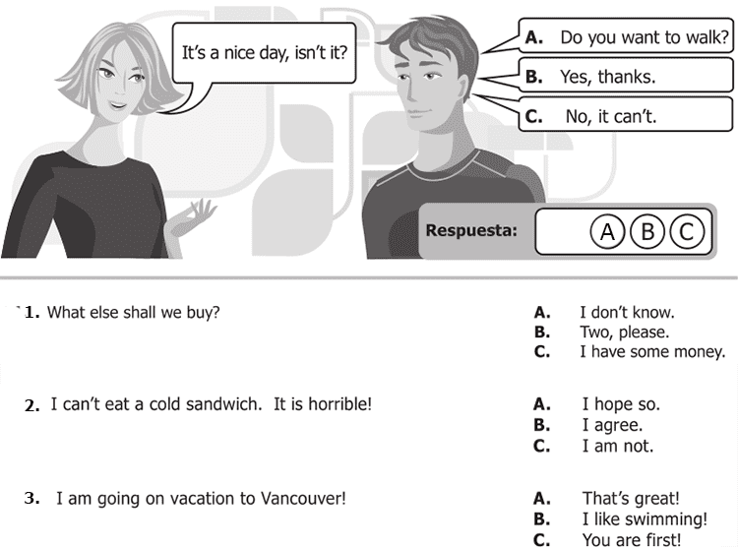

1.On a cold day i can’t go outside without my coat! A .nice

B.great

C. Me too

2.Frien, i’m going on vacation to cancun A. i love you

B. im bored

C.Great friend

3.I called you several times and you did not answer A.so cool

B. yes,i am

C.I’m sorry

4. He’s your boyfriend? A. no

B.he is my teacher

C.yes,is my love

5.Camille is model? A.No,she is arquitec

B.Pink

C.great

**VALERI PORRAS 1103**